Contact Information
Name
Date
Email Address

Instructions:
Please complete the below assessment. When you have finished, send it in to info@bridging-the-gap.com. This must be completed within 2 business days of receiving your online application in step 1.
Please do not email us any questions about the assignment. We want to see how you approach the assignment – and, again, we’re looking for instructors who can help our participants succeed.

Assessment:
- Below is a sample process flow diagram you may receive as part of a participant workbook. Please provide an assessment of the process flow diagram and the email you would write to the participant describing your feedback.
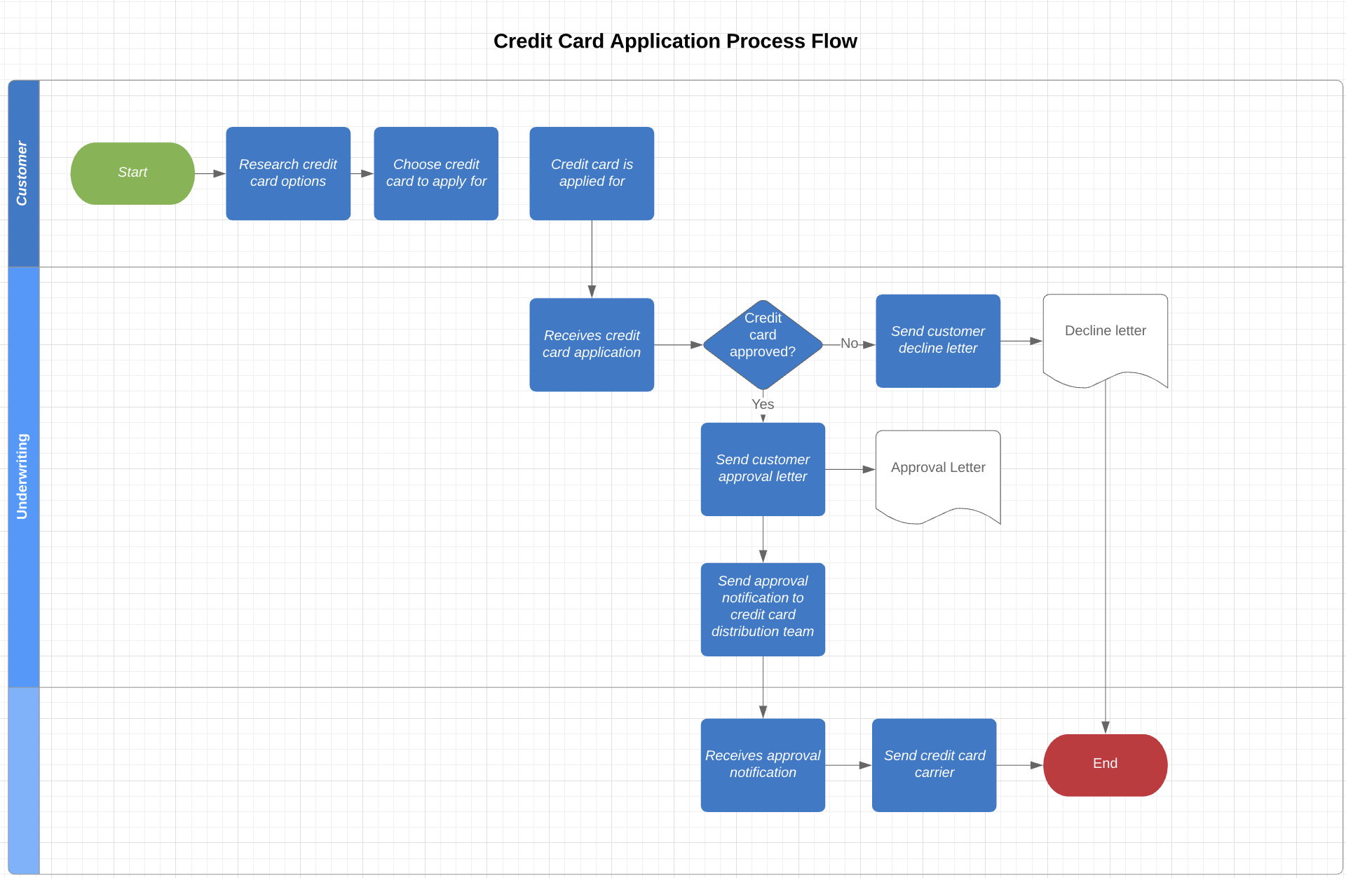

  - Assessment – What specific updates would need to be made?
Click or tap here to enter text.
  - Email Response – What email would you write to the course participant with your assessment?
Click or tap here to enter text.
  - How much time did it take you to complete your feedback and write this email?
Click or tap here to enter text.

- A participant submits the following email with an attached use case that’s using a different template from the course, which is required for successful course completion. What would your response be?

Participant Email
“Good evening,

Here is my use case submission for the UCW module. I was extremely frustrated using the template in the course because my company uses a different template. Whenever I would do a review with stakeholders there would be a comment that the template I was using was incorrect. Since I’m doing a project for my employer, I have decided to use the use case document that my company uses in compliance with their organizational assets.

Regards,
Paula”
Use Case Sample Submitted Bridging the Gap Required Template

  - Email Response
Click or tap here to enter text.
  - How much time did it take you to write this response?
Click or tap here to enter text.

- A participant writes in with the following question about data modeling.
Participant Email:
“I am having trouble constructing the ERD. I am trying to develop the entities and the verb relationships for each entity but I am having a hard time. My entities are:
    - Contacts Module
    - Accounts Module
    - Opportunities Module
    - Proposals Module
    - Activities Module
The Accounts Module is the parent module to all the other modules. Need an account to create a contact. Opportunities and Proposals are linked to contacts and accounts, but mainly accounts and account record owners. Activities are tied to the contacts, opportunities, proposals, and accounts.
Can anyone help me out with some other advice then the video lesson? I have reread the transcript but I am still not getting how to handle the multiplicity here.”
- What would your response be?
Click or tap here to enter text.
- How Much time did it take you to write this response?
Click or tap here to enter text.

