Created by Laura Brandenburg, CBAP

The Business Analysis Process
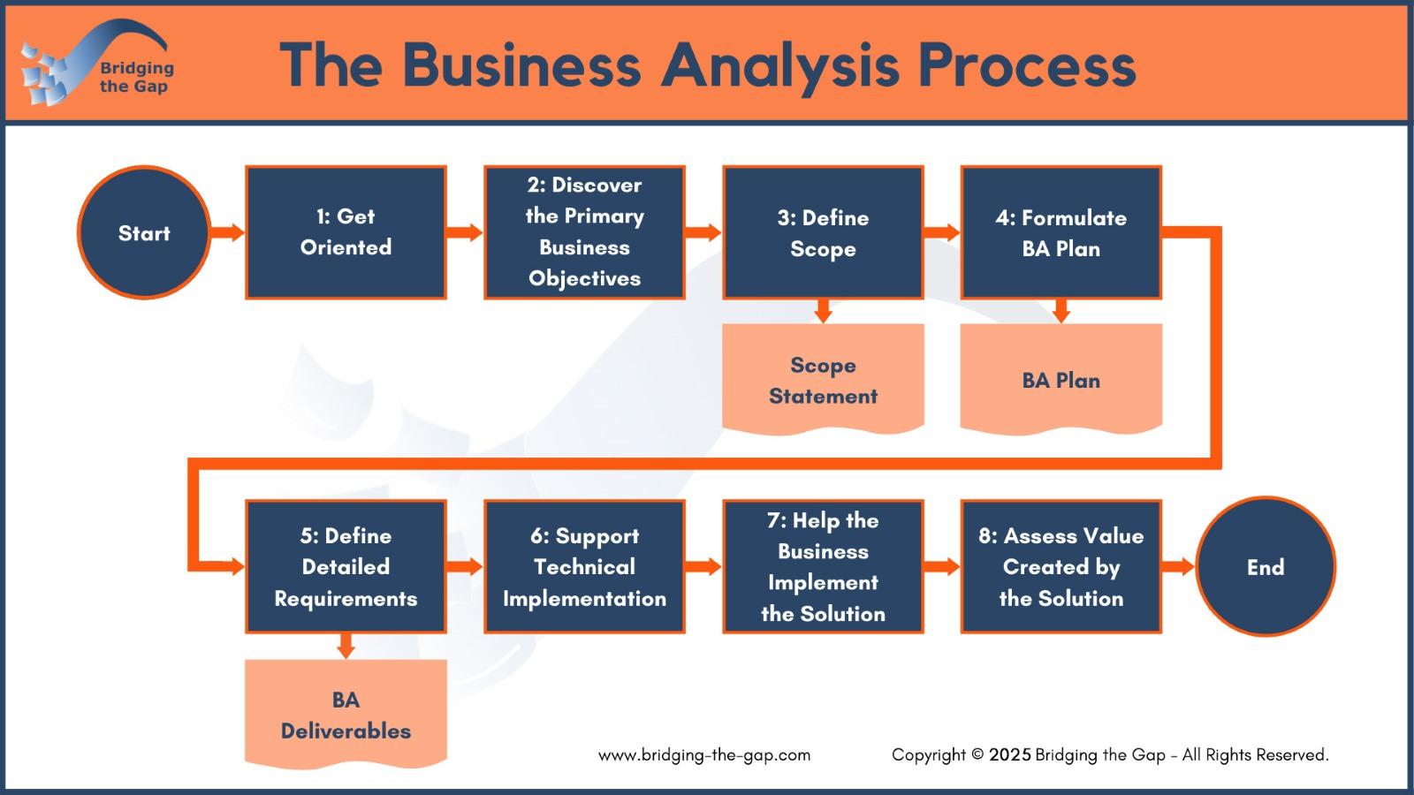

Establish Context
What project, initiative, or team are you assessing today?

Step 1 – Get Oriented
Assessment Question | Rating | Notes
My role is defined and understood by myself and the team.
I am confident that I’ve identified the key stakeholders who influence the initial decisions.
I understand the background, prior decisions, and organizational context for this initiative.
I am familiar with the systems, processes, or tools currently in place, and those are documented appropriately.
The terminology used by this team is well understood and referenced in a glossary or other tool.
I am aware of how generative AI tools can support business analysis tasks across different stages of the process.

Step 2 – Discover the Primary Business Objectives
Assessment Question | Rating | Notes
My business objectives are clearly defined, measurable, and actionable, and represent WHY the change is important to the organization.
There is alignment among stakeholders on the business objectives.
I use process maps or business process analysis to understand the root cause of issues.
I actively invest in building strong, collaborative relationships with stakeholders.

Step 3 – Define Scope
Assessment Question | Rating | Notes
The team has explored multiple solution options, and understand the pros and cons of each.
I use generative AI to generate ideas, explore stakeholder perspectives, generate solution ideas, or challenge assumptions.
The chosen solution approach is appropriate for the business objectives and has stakeholder support.
I stay informed about AI capabilities and help the business implement them where they will provide the most value.
I have conducted an impact analysis to understand how the solution will affect systems, processes, and people.
Requirements have been prioritized based on business value and stakeholder input.
Scope has been documented clearly and concisely in a widely referenced deliverable.
Key stakeholders have reviewed and agreed to the defined scope.
The business case for the initiative has been confirmed and aligns with the defined scope.
I’ve clearly identified system boundaries and interactions (using system context diagrams or a similar technique).

Step 4 – Formulate Your Business Analysis Plan
Assessment Question | Rating | Notes
I have defined the types of deliverables needed to support this initiative.
I have identified the specific deliverables that will be created and communicated during the initiative.
I’ve identified the stakeholders, business and technical, who need to be involved in each deliverable.
I have estimated the time and effort required to complete the analysis work.
I have identified dependencies within the business analysis effort.
I’ve reviewed the business analysis plan with stakeholders and they agree to the time commitment required.
I have sequenced the analysis activities and created a realistic timeline that works well for the team.

Step 5 – Define the Detailed Requirements
Assessment Question | Rating | Notes
I proactively engage stakeholders to discover relevant information about the requirements.
I analyze the information I gather and translate it into clear, structured deliverables.
I use an appropriate combination of use cases, wireframes, and user stories (or other techniques) to analyze and validate the software requirements.
I ensure the business needs are represented by the data/information model, either by completing or reviewing data models.
I appropriately leverage Generative AI to increase my personal productivity.
I experiment with AI tools to draft, improve, or reframe deliverables while maintaining ownership of the final output.
I review and validate requirements with stakeholders, and finalize deliverables based on their feedback.
I effectively facilitate working sessions to collaboratively define and clarify requirements.
I manage scope proactively and help the team stay on track.

Steps 6/7 – Support the Implementation
Assessment Question | Rating | Notes
I support the technical implementation by answering questions, clarifying requirements, and resolving issues as they arise.
I help the business team prepare for and implement the solution effectively.
I create or update current-state documentation to reflect the as-is or transitional workflows.
I revise requirements and manage changes in a structured, transparent way throughout implementation.
I use simulated process walk-throughs or similar techniques to validate how the solution will work in practice.
I help navigate and manage delays or technical challenges that impact implementation.
I actively support the business in owning and adopting the solution after rollout.

Step 8 – Assess the Value Created by the Solution
Assessment Question | Rating | Notes
I assess the quantitative value of the solution using metrics such as time savings, cost reduction, or revenue impact.
I assess the qualitative value of the solution, including user satisfaction, process improvements, and team alignment.
I clearly communicate the results and outcomes of the initiative to relevant stakeholders.
I highlight how business analysis contributed to the success of the initiative.
I reflect on and actively improve my business analysis practices based on lessons learned.
I evaluate and prioritize potential improvement opportunities to enhance long-term results.
I actively reflect on where AI adds value in my work and where human insight and collaboration remain essential.

BONUS – Your Business Analysis Career Path
Assessment Question | Rating | Notes
I understand the stages of the business analyst success path and can identify where I currently am on that path.
I am aware of related roles and career opportunities where I can apply my business analysis skills.
I have identified the type of business analysis work or domain that aligns with my strengths and interests.
I have a clear vision for how I might expand beyond traditional business analysis if I choose to.
I regularly re-evaluate my responsibilities, let go of what is no longer aligned with my career goals, and pursue new activities that expand my value.
I consistently invest in my professional development to grow my skills, confidence, and impact.

Identify Your Strengths
Strength | Value

Identify Improvement Opportunities
Opportunity | Impact  (1-3) | Effort  (1-3)

Choose ONE Improvement Opportunity
Prompt | Your Answer
The scope of this improvement is to…
This is important to me because….

This is valuable to my organization and stakeholders because…

I’ll know I’m successful when…
The next step I can take is…
The support I need is…

Upgrade Your Foundational Business Analysis Skill Set
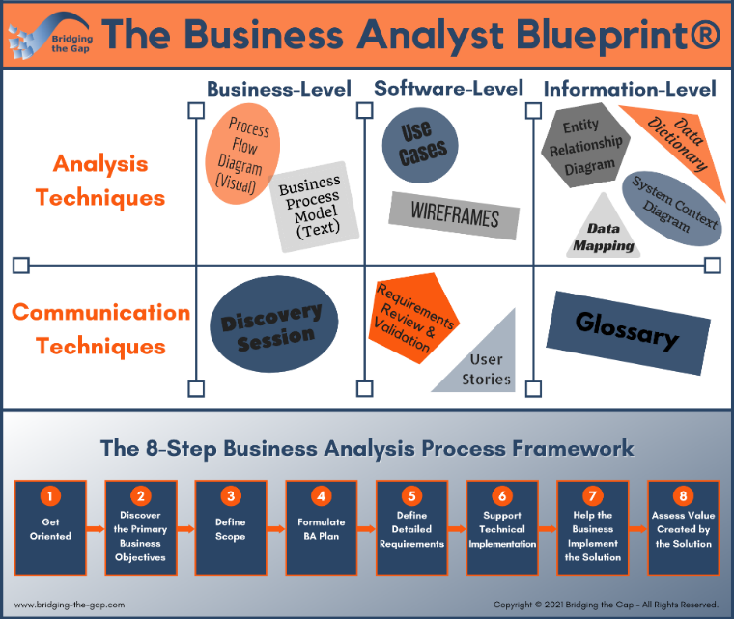
Join me in The Business Analyst Blueprint® training program, which includes in-depth training along with on-the-job coaching, and take your skills and value to the next level.
The program includes:
- Four online training modules you can use immediately: Six months of online access to highly practical, in-depth training videos.
- Practical exercises: Apply what you are learning on-the-job so you make an immediate difference on your projects and starting building real BA experience.
- Feedback and support: Get answers and submit deliverables for feedback in our private community.
- Certificate of Completion (36 PDs): Supporting your certification and re-certification needs from IIBA®.
- Templates and swipe files: Get started with templates, samples, swipe files, and quick reference guides.
- Multiple formats to support every learning style: In addition to Video (mp4) files and audio (mp3) files, you’ll receive fully formatted full-text PDF transcripts.
- Monthly office hours: Monthly group coaching with Laura to answer your questions.
- AI Prompt Library: Includes 30+ curated prompt templates, covering both deliverables and soft skills, that you can copy and paste into any AI tool to enhance your productivity.
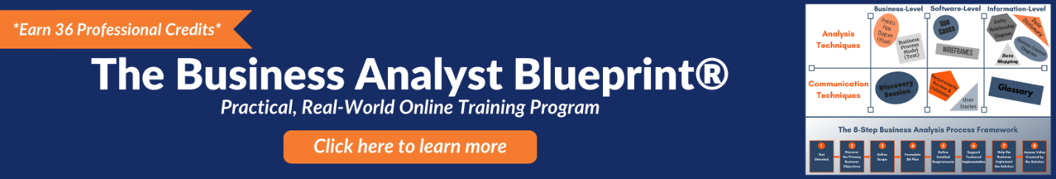

Rank 1-5, where 1 is not addressed, 3 is sometimes true and partially addressed, and 5 is consistently strong and well implemented.

