Created by Laura Brandenburg, CBAP

The Business Analysis Process
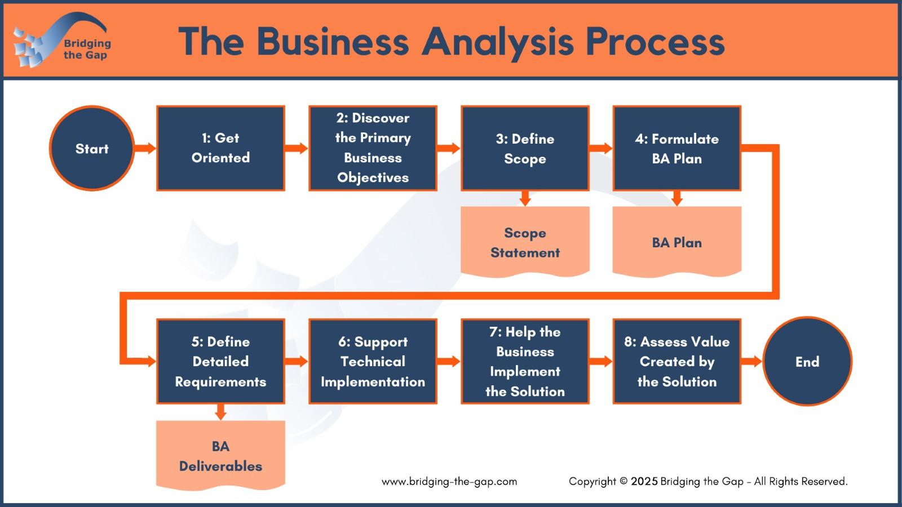

Establish Context
What project, initiative, or team are you assessing today?

Step 1 – Get Oriented
Assessment Question | Rating | Notes
My role is defined and understood by myself and the team.
I understand the history, goals, and organizational context behind this initiative.
I am familiar with the systems, processes, and terminology the team uses.

Step 2 – Discover the Primary Business Objectives
Assessment Question | Rating | Notes
My business objectives are clearly defined, measurable, and actionable, and represent WHY the change is important to the organization.
Stakeholders share a common understanding of the objectives and are aligned on what success looks like.
I use process maps or business process analysis to understand the root cause of issues.

Step 3 – Define Scope
Assessment Question | Rating | Notes
We explore multiple solution options, understand their trade-offs, and select the approach that best meets the business objectives within the established constraints.
The boundaries of the solution – what’s in and out of scope – are clearly documented and agreed upon by the stakeholders.
I’ve analyzed how this solution will impact systems, processes, and people.
I stay informed about AI capabilities and help the business implement them where they will provide the most value.

Step 4 – Formulate Your Business Analysis Plan
Assessment Question | Rating | Notes
I identify the key analysis deliverables and activities needed to support this initiative.
I identify the stakeholders (business and technical) who need to be involved in each deliverable or activity.
I estimate the effort, identify dependencies, and confirm the plan with stakeholders so expectations are realistic and shared.

Step 5 – Define the Detailed Requirements
Assessment Question | Rating | Notes
I actively engage stakeholders to discover, analyze, and clarify the requirements using techniques such as use cases, user stories, or process models.
I leverage appropriate tools, including generative AI, to increase productivity, structure deliverables, and enhance clarity, while maintaining ownership of the final results.
Requirements are reviewed, validated, and updated collaboratively, ensuring they remain aligned with business needs and scope.
I review and validate requirements with stakeholders, and finalize deliverables based on their feedback.
I effectively facilitate working sessions to collaboratively define and clarify requirements.

Steps 6/7 – Support the Implementation
Assessment Question | Rating | Notes
I actively support the technical and business teams during implementation by answering questions, clarifying requirements, and resolving issues promptly.
I help manage requirements or scope changes in a transparent way.
I support the business team in preparing for rollout, updating documentation, and helping them adopt the solution successfully.

Step 8 – Assess the Value Created by the Solution
Assessment Question | Rating | Notes
I assess the quantitative of the solution using metrics such as time savings, cost reduction, or revenue impact.
I assess the qualitative value of the solution, including user satisfaction, process improvements, and team alignment.
I clearly communicate the results and outcomes of the initiative to relevant stakeholders.
I highlight how business analysis contributed to the success of the initiative.
I reflect on and actively improve my business analysis practices based on lessons learned.

BONUS – Your Business Analysis Career Path
Assessment Question | Rating | Notes
I understand where I am in my business analyst career journey and what skills or experiences will help me move forward.
I am clear on the type of business analysis work or domain that best fits my strengths, interests, and long-term goals.
I regularly re-evaluate my responsibilities, letting go of what no longer fits and pursuing opportunities to expand my value.
I consistently invest in my professional development to grow my skills, confidence, and impact.

Identify Your Strengths
Strength | Value

Identify Improvement Opportunities
Opportunity | Impact  (1-3) | Effort  (1-3)

Create a Plan
Choose ONE improvement opportunity and create an initial plan.
Prompt | Your Answer
The scope of this improvement is to…
This is important to me because….

This is valuable to my organization and stakeholders because…

I’ll know I’m successful when…
The next step I can take is…
The support I need is…

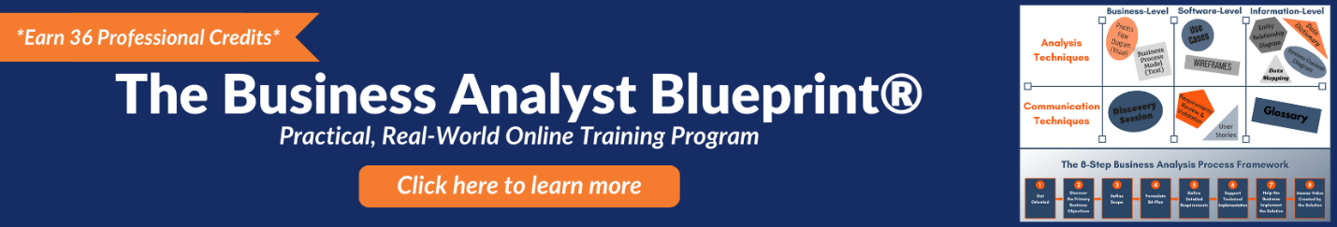

Upgrade Your Foundational Business Analysis Skill Set
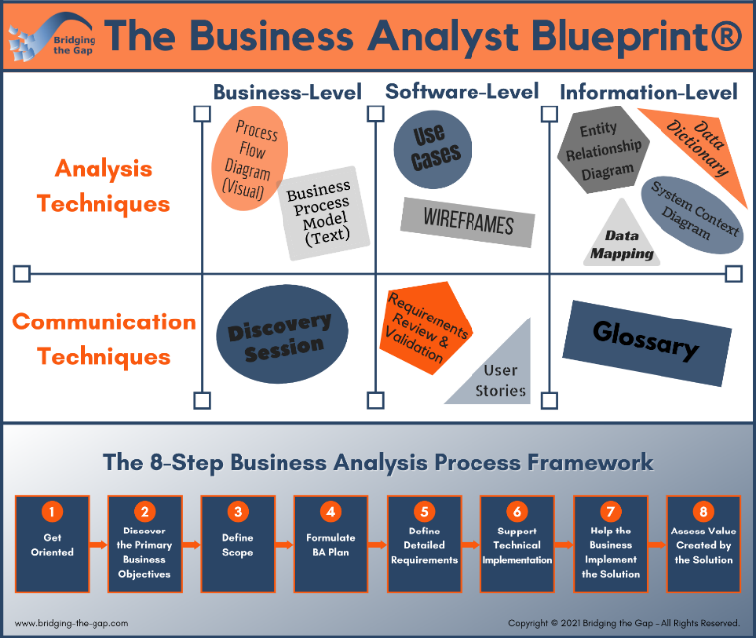
Join me in The Business Analyst Blueprint® training program, which includes in-depth training along with on-the-job coaching, and take your skills and value to the next level.
The program includes:
- Four online training modules you can use immediately: Six months of online access to highly practical, in-depth training.
- Practical exercises: Apply what you are learning on-the-job so you make an immediate difference on your projects and starting building experience.
- Feedback and support: Get answers and submit deliverables for feedback in our private community.
- Certificate of Completion (36 PDs): Supporting your certification and re-certification needs from IIBA®.
- Templates and swipe files: Get started quickly with value-added work aids.
- Multiple formats to support every learning style: In addition to Video (mp4) files and audio (mp3) files, you’ll receive full-text transcripts.
- Monthly office hours: Monthly group coaching with Laura.
- AI Prompt Library: Includes 30+ curated prompt templates, covering both deliverables and soft skills.

Rank 1-5, where 1 is not addressed, 3 is sometimes true and partially addressed, and 5 is consistently strong and well implemented.

